Extrapolation Estimation Technique

📌 What is Extrapolation in Test Estimation?
# Source: AI Source: Provided by: [Data Path: Persons Table -> ID Column: 1, Name_En Column: Motasem Essam] -> From: [Chatgpt (GPT‑5 Mini)] on [8/24/2025]
Extrapolation is an estimation technique where effort, time, or cost is predicted by using historical data from previous projects (or past phases of the current project) and applying it to the new project, adjusting for size/complexity differences.
👉 In simple words:
“Use past project data to estimate the future.”

🗂️ Steps in Extrapolation
# Source: AI Source: Provided by: [Data Path: Persons Table -> ID Column: 1, Name_En Column: Motasem Essam] -> From: [Chatgpt (GPT‑5 Mini)] on [8/24/2025]
- Collect historical data (e.g., test effort for similar past projects).
- Identify key metrics (e.g., effort per requirement, defects per module, test cases per function).
- Compare project sizes (old vs new project scope).
- Apply scaling factor (e.g., 20% bigger = 20% more effort).
- Adjust for complexity/risks.

📊 Example of Extrapolation
# Source: AI Source: Provided by: [Data Path: Persons Table -> ID Column: 1, Name_En Column: Motasem Essam] -> From: [Chatgpt (GPT‑5 Mini)] on [8/24/2025]
Suppose:
- Last project (Banking App v1):
  - 100 test cases took 200 hours.
- New project (Banking App v2):
  - Scope: ~150 test cases (50% more).
👉 Estimate using Extrapolation:
- (200 hours / 100 test cases) = 2 hours per test case.
- New project (150 test cases × 2 hours) = 300 hours.
✅ Final Estimated Effort = 300 hours

✅ Advantages
# Source: AI Source: Provided by: [Data Path: Persons Table -> ID Column: 1, Name_En Column: Motasem Essam] -> From: [Chatgpt (GPT‑5 Mini)] on [8/24/2025]
- Simple and data-driven.
- Uses real past experience, not just intuition.
- Good when projects are similar (same domain, same tech).

⚠️ Disadvantages
# Source: AI Source: Provided by: [Data Path: Persons Table -> ID Column: 1, Name_En Column: Motasem Essam] -> From: [Chatgpt (GPT‑5 Mini)] on [8/24/2025]
- Only works if reliable historical data exists.
- May be inaccurate if the new project is very different (new technology, bigger team).
- Ignores non-linear complexity (e.g., doubling scope may triple effort).

🔑 Comparison with Other Techniques
# Source: AI Source: Provided by: [Data Path: Persons Table -> ID Column: 1, Name_En Column: Motasem Essam] -> From: [Chatgpt (GPT‑5 Mini)] on [8/24/2025]
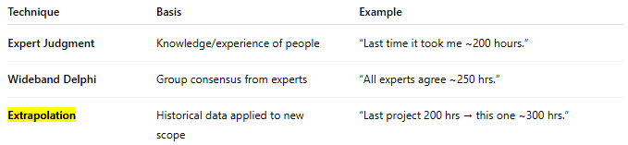
Technique | Basis | Example
Expert Judgment | Knowledge/experience of people | “Last time it took me ~200 hours.”
Wideband Delphi | Group consensus from experts | “All experts agree ~250 hrs.”
Extrapolation | Historical data applied to new scope | “Last project 200 hrs → this one ~300 hrs.”

👉 So, Extrapolation = Historical data–based estimation.

Is Extrapolation AND Wideband Delphi Technique ARE SAME
# Source: AI Source: Provided by: [Data Path: Persons Table -> ID Column: 1, Name_En Column: Motasem Essam] -> From: [Chatgpt (GPT‑5 Mini)] on [8/24/2025]
👉 No, Extrapolation and Wideband Delphi are not the same.
They are different estimation techniques, used in different ways. Let’s break it down:

📌 Extrapolation
# Source: AI Source: Provided by: [Data Path: Persons Table -> ID Column: 1, Name_En Column: Motasem Essam] -> From: [Chatgpt (GPT‑5 Mini)] on [8/24/2025]
- Basis: Historical project data.
- Approach: Use actual numbers from past projects (e.g., test cases, hours, defects) and scale them for the new project.
- Nature: Data-driven (objective).
Example:
- Past project: 100 test cases took 200 hours.
- New project: 150 test cases → estimated 300 hours.
✅ Effort = calculated from past data.

📌 Wideband Delphi
# Source: AI Source: Provided by: [Data Path: Persons Table -> ID Column: 1, Name_En Column: Motasem Essam] -> From: [Chatgpt (GPT‑5 Mini)] on [8/24/2025]
- Basis: Expert opinions.
- Approach: A group of experts give independent estimates → discuss differences → re-estimate until consensus is reached.
- Nature: Expert-driven (subjective but collaborative).
Example:
- 5 experts estimate testing: 250 hrs, 270 hrs, 400 hrs, 280 hrs, 260 hrs.
- They discuss why one person gave 400 hrs, adjust for assumptions.
- Final consensus: ~280 hrs.
✅ Effort = calculated from expert judgment.

🔑 Key Difference
# Source: AI Source: Provided by: [Data Path: Persons Table -> ID Column: 1, Name_En Column: Motasem Essam] -> From: [Chatgpt (GPT‑5 Mini)] on [8/24/2025]
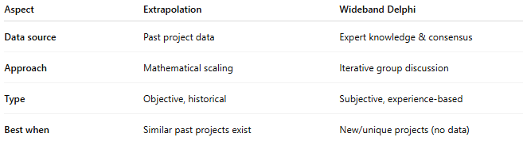

Aspect | Extrapolation | Wideband Delphi
Data source | Past project data | Expert knowledge & consensus
Approach | Mathematical scaling | Iterative group discussion
Type | Objective, historical | Subjective, experience-based
Best when | Similar past projects exist | New/unique projects (no data)

✅ Conclusion:
- Extrapolation = "What happened before will happen again" (data-driven).
- Wideband Delphi = "What experts think will happen" (discussion-driven).

